# NavCampus

# Vision

# Version <1.3>

# Revision History

|  |  |  |  |
| --- | --- | --- | --- |
| **Date** | **Version** | **Description** | **Author** |
| 09.11.2023 | 1.0 | Introduction, Positioning and stakeholders | Nico Kopitza |
| 14.11.2023 | 1.1 | Product Overview and Features | Nico Kopitza |
| 18.11.2023 | 1.2 | Constraints, quality ranges and prioritization | Nico Kopitza |
| 22.11.2023 | 1.3 | Requirements and adjustment of previous sections | Nico Kopitza |

# Table of Contents

1. Introduction 5

1.1 Purpose 5

1.2 Scope 5

1.3 Definitions, Acronyms, and Abbreviations 5

1.4 References 5

2. Positioning 5

2.1 Business Opportunity 5

2.2 Problem Statement 5

2.3 Product Position Statement 6

3. Stakeholder and User Descriptions 6

3.1 Market Demographics 6

3.2 Stakeholder Summary 6

3.3 User Summary 7

3.4 User Environment 7

3.5 Stakeholder Profiles 7

3.5.1 University 7

3.5.2 Team NavCampus 8

3.6 User Profiles 8

3.6.1 Visually impaired students 8

3.7 Key Stakeholder or User Needs 9

3.8 Alternatives and Competition 9

3.8.1 Status quo

3.8.2 Other teams 9

4. Product Overview 10

4.1 Product Perspective 10

4.2 Summary of Capabilities 10

4.3 Assumptions and Dependencies 10

4.4 Cost and Pricing 10

4.5 Licensing and Installation 10

5. Product Features 11

5.1 Navigation 11

5.2 Object Detection 11

5.3 Fall Detection and Emergency Call 11

5.4 Voice Input and Output 11

5.5 Route Calculation 11

5.6 User Feedback Mode 11

5.7 High-Contrast UI 11

5.8 Map Identifiers 12

5.9 Encrypted Data Transmission 12

5.10 Machine Learning 12

6. Constraints 12

7. Quality Ranges 12

8. Precedence and Priority 12

9. Other Product Requirements 12

9.1 Applicable Standards 12

9.2 System Requirements 13

9.3 Performance Requirements 13

9.4 Environmental Requirements 13

10. Documentation Requirements 13

10.1 User Manual 13

10.2 Online Help 13

10.3 Installation Guides, Configuration, and Read Me File 13

10.4 Labeling and Packaging 13

# Vision

# Introduction

The “NavCampus” is a web app that supports blind people in navigating on campus, especially in buildings. The system will make use of an internal three-dimensional map of the buildings. On multiple locations there will be signs to give the app the user's location. The GPS system will provide the direction the user looks, so that the system can provide the way the user needs to go to a desired room; as well as an estimated number of steps they need to take. Also, it provides an object identification system.

## Purpose

This document is made to clarify the needs for the system as well as describing the users and the stakeholders. Further it will provide reference to what the goal of the project will look like.

## Scope

This vision document provides the proposed model for the NavCampus App. This document will be used in connection with the WRS document to build the product (App) of the project.

## Definitions, Acronyms, and Abbreviations

-

## References

WRS document – 23.10.2023 – NavCampus Team

# Positioning

## Business Opportunity

The proposed system will help visually impaired students navigate the Cal Poly Humboldt campus safely. At the time there is no system in place to help this group to find their way across the campus, so they are dependent on the help of other students or staff members. The NavCampus App will give these students a way to be more independent and safe on campus and therefore making the school more attractive for those to attend.

## Problem Statement

|  |  |
| --- | --- |
| The problem of | * Not being able to navigate on campus independently |
| affects | * Visually impaired students and staff members |
| the impact of which is | * The impacted could get lost on campus or be late to their classes or could decide to choose a different university |
| a successful solution would be | * a cheap and easy to distribute system that provides navigation as well as an object identifier to prevent collisions and accidents |

## Product Position Statement

|  |  |
| --- | --- |
| For | * Visually impaired students |
| Who | * Making the university more attractive for those students and giving them the same opportunity’s |
| The NavCampus App | * is a mobile application |
| That | * Offers navigation fall detection and object detection |
| Unlike | * The nonexistent system on the Cal Poly Campus |
| Our product | * Will be usable by all students but will be catered towards the blind ones |

# Stakeholder and User Descriptions

This section focuses on the stakeholders and users. These will be described and also their expectations for the project will be stated.

## Market Demographics

Now the demographics of visually impaired students is small. But this could be caused by the momentarily state that they don’t get the support they need to attend this university. In cooperation with the university, we plan to change the momentarily state and give these potential students the equal opportunity to strive to their full potential. So, our team plans to make this the new reality with this project. Our intended App will be a important step in the this direction by giving our users more independence to roam the campus and find their way to go.

## Stakeholder Summary

|  |  |  |
| --- | --- | --- |
| **Name** | **Description** | **Responsibilities** |
| * Cal Poly Humboldt University | * The main customer and cooperator of the project | * ensures that the system will be maintainable * promotes the project after publication * monitors the project’s progress * approves funding * helps monitoring objects on campus * supports the project with the necessary hardware * gets the approval of being filmed from staff and students |
| * Team NavCampus | * The developers and designers of the system | - produces the product  - monitors the project  - overviews the project  ­- ensures that the system will be maintainable   * Making sure the system is safe |

## User Summary

|  |  |  |  |
| --- | --- | --- | --- |
| **Name** | **Description** | **Responsibilities** | **Stakeholder** |
| * Visually impaired student and staff | * Target audience | * In final testing phases giving feedback * Using the app according to manual | * advocates of blind students, help workers |
| * Students and staff members | * Secondary audience | * Using the app according to manual * Do not demand changes for seeing students with the feedback function | * Because they are not the primary audience they will not be taken into account |

## User Environment

The users need to find their way around campus but are dependent on the help of other students and/or staff members. This can lead to them being late to classes or not finding their classrooms at all. Also, the terrain on campus is hard to traverse because of the many steep stairs. This can lead to falls. On the other hand is this navigation very time consuming which reduces the time the potential user can use on networking or studying. This is a disadvantage to the other students. The only system in place to support them right now is the braille inscription on the room signs. But this is only useful when the person already arrived at the location. Some of the users may use google maps to traverse campus. This system doesn’t know about the streets on campus and cannot help with finding the right room in a building. This is especially hard because the campus lies on a hill and the user will not always goes into a building on the first floor. This makes navigation even harder on them.

## Stakeholder Profiles

### University

|  |  |
| --- | --- |
| **Description** | * Cooperator and Customer |
| **Type** | * business |
| **Responsibilities** | * hardware support * getting approval of filming of staff members and students * helping with updating the internal map of the system * promoting the app |
| **Success Criteria** | * being more attractive for visually impaired students * Less money spent on staff to support the users. * Financially when more students come to the university |
| **Involvement** | * Tester, Trainer, and Owner |
| **Deliverables** | / |
| **Comments / Issues** | * The university wants to use the least amount of resources possible |

3.5.2 Team NavCampus

|  |  |
| --- | --- |
| **Representative** | * Chan Rain, Nico Kopitza |
| **Description** | * developer |
| **Type** | * expert |
| **Responsibilities** | * creating the system * making the system maintainable |
| **Success Criteria** | * The product is fully functional and helps visually impaired students. * No compensation |
| **Involvement** | * Project manager/coordinator, architect, analyst, developer, technical writer |
| **Deliverables** | * WRS, Vision document, multiple graphs regarding requirement, presentation |
| **Comments / Issues** | / |

## User Profiles

### Visually impaired students/staff

|  |  |
| --- | --- |
| **Description** | * Students and staff members that are classified as blind |
| **Type** | * Casual user |
| **Responsibilities** | * Using the system in the intended way * Giving feedback |
| **Success Criteria** | * Being independent in navigating campus safely * Being closer to have the same opportunity as peers |
| **Involvement** | * Tester |
| **Deliverables** | * / |
| **Comments / Issues** | * / |

## Key Stakeholder or User Needs

|  |  |  |  |  |  |
| --- | --- | --- | --- | --- | --- |
| **Need** | **Priority** | **Concerns** | **Current Solution** | **Proposed Solutions** | |
| Navigation | 1 | Choosing a unsafe route, not finding a route at all | Help from staff/students | | Navigation app |
| Getting location | 1 | Problems with finding the location of user in a building | / | | Using identifiers on rooms and entrances in combination with GPS |
| Object detection | 1 | Accidents caused by collisions | Use of cane | | Use of cane in combination with a camera-based system to change route |
| Audio instructions | 1 | The user is not able to follow the instructions | Visual maps | | The apps give the navigation in form of audio files |
| Fall detection | 2 | User doesn’t get help for a extended period of time | Hoping that somebody finds user | | Fall detector of phone in combination with calling UPD |
| Feedback | 3 | App is missing some important feature, or a feature doesn’t work | / | | Option to give feedback inside the app that is transferred directly to the Dev Team |

## Alternatives and Competition

### Status quo

Pro: - no extra resources needed

- no changes in system

Con: - some students at a disadvantage

- no new students out of the target group

- more use of staff on helping users

### Other teams project

Pro: - good solutions

Con: - would take more resources to implement

# Product Overview

## Product Perspective

There are two different approaches in place right now. One is the use of the cane and asking for direction across campus to find the destination. The other possibility is using google maps, but this application doesn’t support the routes inside the campus, so it isn’t usable even, so it has approaches to be used by blind people.

The system will be installed on a mobile phone, preferably a smartphone. Therefore, it is implemented in the bigger system of the device. The app will have access to the device’s sensors. The needed sensors are a camera, a fall sensor, the GPS location, and the step counter.

## Summary of Capabilities

|  |  |
| --- | --- |
| **Feature** | **Functioning** |
| Finding the location | An internal map has identifiers on every room and entrance that can be scanned so the system knows the location |
| Object detection | The system can identify objects and the distance to them using the devices camera |
| Fall detection | The system uses the devices sensors to detect a fall and can call UPD if needed |
| Audio input and output | The system gives the navigation using audio files and can also understand the audio input of the user to find the destination |
| Safe route calculation | The system can find the safest route (less stairs) on campus between two identifiers and give the user the necessary instructions |

|  |  |
| --- | --- |
| Element | Detail |
| § | Navigation |
| ID | 1 |
| Description | Standard navigation sequence |
| Actors | User |
| Organization benefit | Main function of the app, provides navigation to the user using a system that is accessible for blind people |
| Frequency of use | Almost always |
| Triggers | Tapping on the screen |
| Preconditions | User is in the NavCampus App, User is on Cal Poly Humboldt campus |
| Postconditions | User arrived at their destination |
| Main Course | 1. Tap screen to activate navigation sequence 2. User scans identifier 3. User puts in their wished destination 4. System calculates route 5. System starts object detection 6. System displays and audio outputs navigation 7. User follows instructions 8. User arrives at destination |
| Alternate Course | 1. Tap screen to activate navigation sequence 2. User scans identifier 3. User puts in their wished destination 4. System calculates route 5. System starts object detection 6. System displays and audio outputs navigation 7. User cancels navigation 8. Navigation ends |
| Exception course | 1. Tap screen to activate navigation sequence 2. User scans identifier 3. User puts in their wished destination 4. System calculates route 5. System starts object detection 6. System displays and audio outputs navigation 7. User falls 8. System detects fall and starts fall function |

|  |  |
| --- | --- |
| Element | Detail |
| Name | Fall function |
| ID | 2 |
| Description | Can call for help in case of a fall with an unconscious user |
| Actors | User, UPD |
| Organization benefit | Increases safety of visual impaired students |
| Frequency of use | In the best case never, should be rare if user still uses cane like instructed |
| Triggers | Fall detection register fall |
| Preconditions | User uses NavCampus App with activated Navigation |
| Postconditions | User gets help or is okay after fall |
| Main Course | 1. User falls 2. System detects fall 3. Fall function starts 4. Timer starts (30 seconds) 5. Timer completes 6. System calls UPD 7. System provides location of user to UPD 8. Navigation stops 9. System stays in emergency timer screen |
| Alternate Course | 1. User falls 2. System detects fall 3. Fall function starts 4. Timer starts (30 seconds) 5. User taps screen three times to stop timer 6. Timer stops 7. Fall function stops 8. Navigation continuous |
| Exception course | 1. Device falls 2. System detects fall 3. Fall function starts 4. Timer starts (30 seconds) 5. User taps screen three times to stop timer 6. Timer stops 7. Fall function stops 8. Navigation continuous |

## 4.2 Assumptions and Dependencies

The most important dependency is that the university gets the permission of the students and the staff that the app is allowed to film them, so the object detection works. Without this permission an alternative solution must be found.

The main assumption is that the user has a mobile device with the necessary sensors.

Also, the cane is to be used when the user normally uses one, because without this safety can’t be guaranteed.

## Cost and Pricing

The main cost of this project lies in maintaining the serves and the licenses to distribute the app using the apple App Store and the google play store. Other cost restrains are not known now.

## Licensing and Installation

The app will be available in the Apple App Store and the Google Play store. Therefore, there shouldn’t be any complications regarding installation and licensing.

# Product Features

## Navigation

Description: NavCampus offers step-by-step audio guidance, aiding visually impaired users in reaching every location on the Cal Poly Humboldt campus.

Functionality: Leverages the internal three-dimensional map, GPS, and room/entrance identifiers for navigation.

## Object Detection

Description: The app identifies and alerts users about obstacles in their path, ensuring safety and preventing collisions.

Functionality: Utilizes the device's camera and machine learning for real-time object detection.

## Fall Detection and Emergency Call

## Description: NavCampus includes a fall detection system, initiating a countdown. In case of a fall, users can deactivate the countdown, or the app triggers an emergency call to the university police department, sharing the GPS location.

## Functionality: Integrates fall detection from device sensors and facilitates emergency procedures.

## Voice Input and Output

## Description: Users can interact with the app using voice commands to set destinations, receiving navigation instructions through audio files.

## Functionality: Uses voice recognition for user input and delivers navigation guidance through audio files.

## Route Calculation

## Description: The system calculates the safest route on campus, prioritizing paths with fewer stairs to enhance user safety.

## Functionality: Considers internal maps, GPS data, and identifiers to compute the safest route between locations.

## User Feedback Mode

## Description: NavCampus allows users to provide feedback through audio recordings within the app.

## Functionality: Activated by tapping the screen three times, records feedback, and forwards audio files directly to the dev team.

## High-Contrast UI

## Description: The app features a high-contrast interface with distinct colors ensuring better usability for users with partial sight.

## Functionality: Displays the interface with high-contrast colors for improved visibility.

## Map Identifiers

## Description: Internal maps incorporate identifiers for each room and entrance, for location detection.

## Functionality: Identifiers linked to numbers on door signs and entrances for recognition.

## Encrypted Data Transmission

## Description: All data transmitted by the app is encrypted, securing the security and privacy of user information and other students and staff members data collected by the camera.

## Functionality: Implements encryption algorithms for data security.

## Machine Learning

## Description: The app uses machine learning algorithms to continuously improve object detection accuracy through the device's camera.

## Functionality: Constantly learns and adapts to identify objects and estimate distances more effectively.

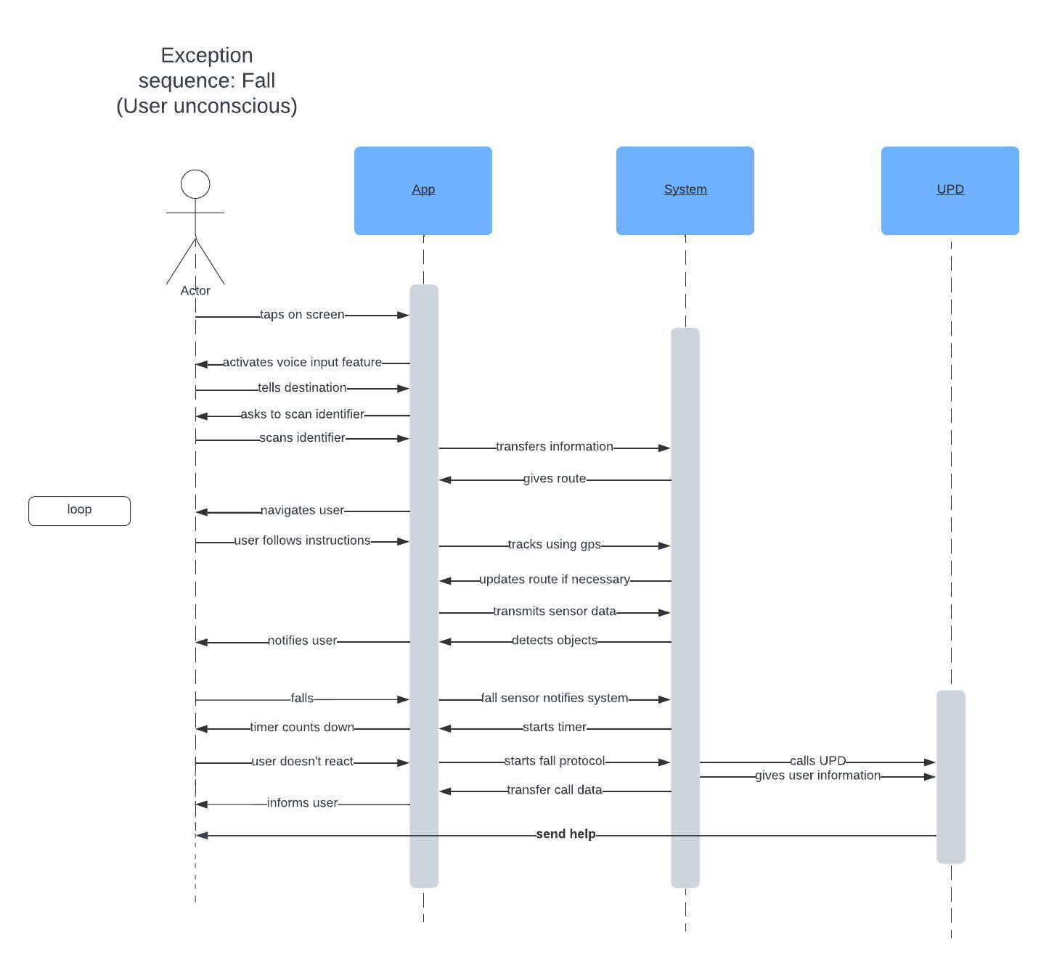

# Constraints

The design needs to be of high contrast so that not completely blind users can see the instructions on screen more easily.

Also there needs to be reminder to use the cane when that would be normally the case for the user.

The user needs to have a internet connection so that the algorithm can learn and adapt.

# Quality Ranges

The system is not allowed to stop in all scenarios to ensure safety for the user.

The performance needs to be quick enough so that it doesn’t need to buffer in between instructions.

The system cannot fail to announce stairs or objects to prevent injuries.

The calculated route should not be wrong at any time, but the error is of lesser priority.

The system needs to be robust enough that it will not break in the middle of navigation.

# Precedence and Priority

The navigation and safety measures have the highest priority as well as features regarding the ease of use for visually impaired students.

The other system like feedback and data security have secondary priority.

# Other Product Requirements

## Applicable Standards

Usable on common mobile operating systems: iOS, Android

Legal standards: HIPAA, CCPA, CalOPPA

## System Requirements

The device needs to run on iOS or Android.

Further requirements regarding needed memory and CPU power will be added in later stages of development but a device that is 5 years old should be able to run the app.

## Performance Requirements

The app needs to be able to run stable in all circumstances. That means it can’t break down in buildings or when the service of the device breaks down for a moment. It should be stable enough to not needing to buffer for longer periods of time. Object detection and instructions should be immediate.

## Environmental Requirements

The app is part of the device so it should work as long as the device is functional. The web app design cannot impede device failure.

# Documentation Requirements

## User Manual

The User manual shall include how to use the web app and access all features in a way that is easy to understand when you just listen to it. The format should be in writing and as an audio file. Because of the audio file format, it shouldn’t be too long so the user can concentrate through the whole document. The level of detail is not too high because of the simplicity of the web app.

The goal is to instruct users as well as staff to use the web app to its full capacity.

## Online Help

The university shall promote the web app and provide a help page on the home page of the university regarding the app.

There shall also be a telephone number to contact to get help regarding the web app.

## Installation Guides, Configuration, and Read Me File

The app shall be easily accessible via a web browser, so all users will be able to use it without installing anything to their device. The URL will be unique and memorable, as to not cause confusion about where users can find our app.

## Labeling and Packaging

The app shall be called NavCampus and be available to use for free on the web.